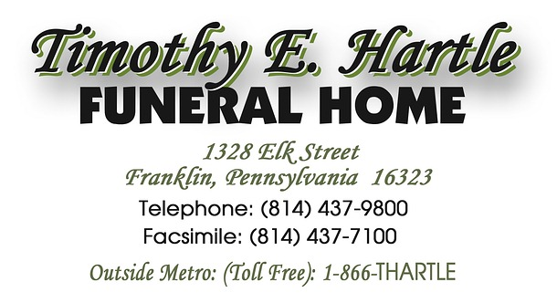
tehartle@verizon.net
Please fill out form . . . . e-mail, mail or bring completed form with you when we meet.
(To print, go to file and hit PRINT-OK / Make sure you save file to your computer.)

Personal Information

Name (First Middle Last):
Marital Status:
Date of Birth:
Place of Birth:
Address:
City: State:
County: Zip:
Phone: E-mail:
Spouse's Name:
Spouse's Maiden Name:
Place of Marriage:
Date of Marriage:
Father's Name:
Mother's Name:
Mother's Maiden Name:
Informant:
Address:
Phone:

Personal Information

Education & Work History

Education: College:
Occupation:
Business: Company:

Military Record

Branch of Service: Serial Number:
Date Enlisted: Rank at Discharge:
Date Discharged: Discharge on File at:
Participated in Wars:

Funeral Service Request

Place of Service:
Funeral Home:
Address:
Phone:
Place of Visitation:
Religious Denomination:
Place of Worship:

Newspaper Information

Please list family members

Children:

Brothers / Sisters:

Number of Grandchildren:
List any other significant relatives:

Special Instructions

Organizations:
1.
2.
3.

Jewelry / Glasses:

Do you have an existing Pre-Arrangement with another funeral home?

Person in Charge of Arrangements:

Memorials / Donations to Charity

